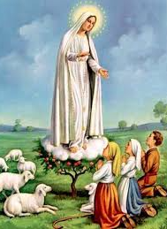

St. Joseph’s Young Priest Society

Decade of the Rosary and The Angelus

At 12 noon on Saturday 13th May 2017 please say a decade of the Rosary and the Angelus for Vocations to the Priesthood.

